- N-type semiconductors have free electrons, P-type semiconductors have free holes which act like positive ions.
- Naturally, P-and N-type semiconductors form a depletion region in the middle space, resulting in an electric field. With a forward-bias, the electric field is weakened or eliminated, allowing electrons to flow through and forming a current. With a reverse-bias, the electric field is strengthened, blocking the electrons to flow through, so there will be almost no current.
- Being ideal means being simple and easy to calculate. For example, an ideal power supply has no inner resistance, an ideal diode has no voltage drop etc.
- 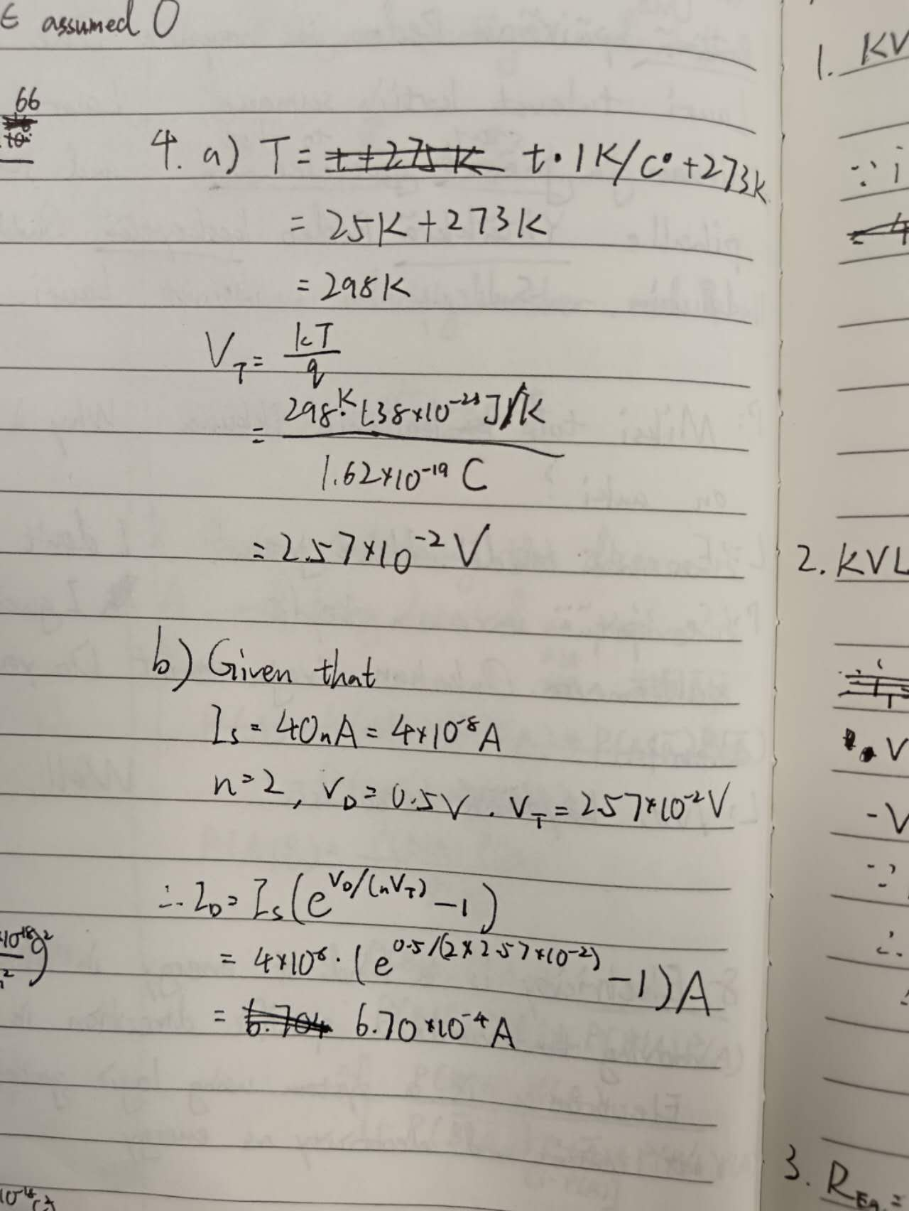
In this lesson, I gained basic understanding of semiconductor and diode, and became familiar with their basic applications.

